Dear Applicant,

Please find enclosed an application pack for the post of Partnership and Policy Manager. Please complete the application form fully giving examples and evidence of how you meet the criteria set out in the person specification. If you require any assistance, please get in touch.

As a voluntary organisation, we do not confirm receipt of applications. Please complete the application form enclosed and return to the address below no later than 9 pm on 6th June 2025. Interview date to be arranged.

If short listed, you will receive a letter inviting you for an interview.

I look forward to receiving your application.

Yours sincerely

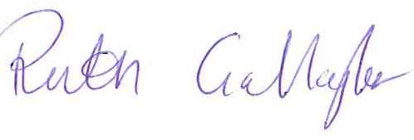

**Ruth Gallagher**

**Chief Officer**

Enclosures:

Job Description & Person Specification

Application Guidelines

Application Form