Dear Applicant,

Please find enclosed an application pack for the post of Youth Lead Worker. Please complete the application form fully giving examples and evidence of how you meet the criteria set out in the person specification. If you require any assistance, please get in touch.

As a voluntary organisation, we do not confirm receipt of applications. Please complete the application form enclosed and return to the address below no later than 9 pm on 1st June 2025. Interviews will be held on 4th June 2025.

If short listed, you will receive a letter inviting you for an interview.

I look forward to receiving your application.

Yours sincerely

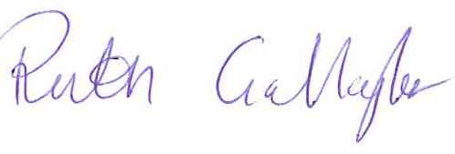

**Ruth Gallagher**

**Chief Officer**

Enclosures:

Job Description & Person Specification

Application Guidelines

Application Form